ECE 243 project
Group member: Weiqing Zhang, Yunhuan Zou
Project name: tank’s war
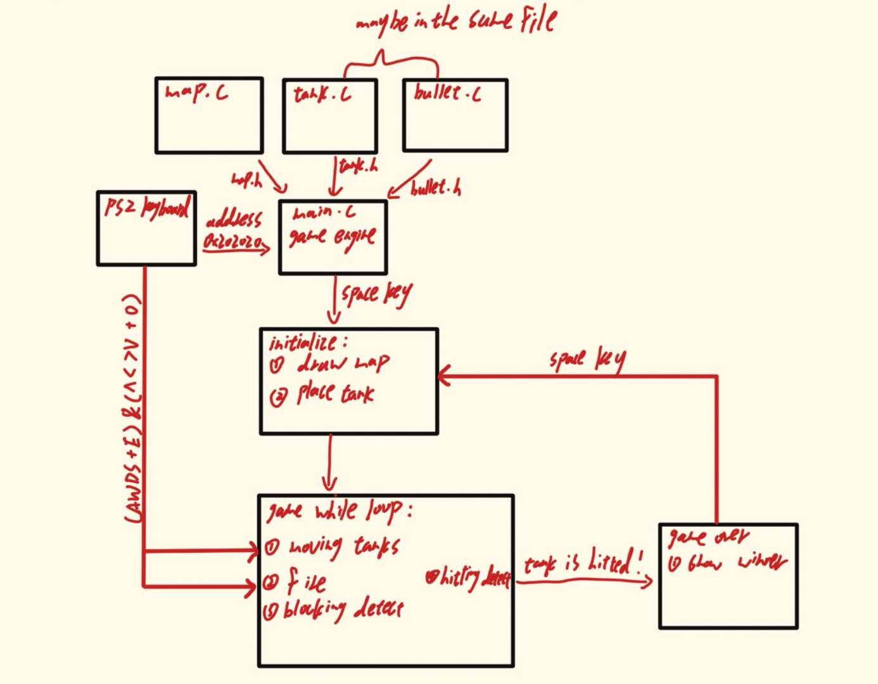
Block diagram

This project is a two-player battle game where Player 1 (left side) uses AWDS keys to move and Q to fire, while Player 2 (right side) uses JIKL keys to move and P to fire. Randomly generated obstacles appear on the screen to block movement and bullets. When a bullet hits the opponent, a sound effect plays, and the game immediately displays a victory message like "Player 1 Wins!" Both movement and firing actions are accompanied by distinct sound effects. The game ends as soon as one player is hit, declaring the winner clearly.

